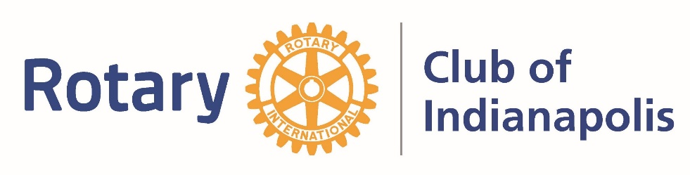
Nominations Open for ROAR Award
The Rotary Club of Indianapolis is proud to announce that nominations for the Rotary Outstanding Achievement Recognition (ROAR) Award is open (formerly called Rotarian of the Year.) Nominations for Rotarians in good standing who have demonstrated “Service Above Self” during his or her lifetime are being accepted. This award recognizes a life devoted to reflecting the Four Way Test, not just within the Club, but in their career and community life as well. This is considered a lifetime achievement award.
Award Information:
1. Completed nominations should be submitted no later than May 12, 2023, to Jamie Hanan via email to jhanan@indyrotary.org or mailed to Rotary Club of Indianapolis, 3202 North Meridian Street, Indianapolis, IN 46208.
3. Public announcement of the ROAR Award will occur on June 6 and the award will be presented at the 2023 Celebration Event scheduled for the evening of June 27.

2023 ROAR Award Nomination Form
Must be submitted no later than May 12, 2023.
Name: _____________________________________________________________
Why do you think this person is deserving of the Rotary Outstanding Achievement Recognition Award?

______________________________________________________________________________________________________________________________________________________________________________________________________________________________________________________________________________________________________________________________________________________________________________________________________________________________________________________________________________________________________________________________________________________________________________________________________________________________________________________________________________________________

