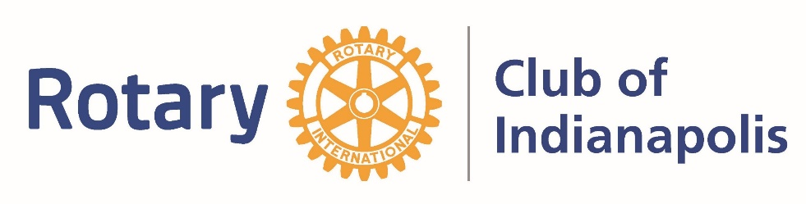
Nominations Open for ROAR Award
The Rotary Club of Indianapolis is proud to announce that nominations for the Rotary Outstanding Achievement Recognition (ROAR) Award is open (formerly called Rotarian of the Year.) Nominations for Rotarians in good standing who have demonstrated “Service Above Self” during his or her lifetime are being accepted. This award recognizes a life devoted to reflecting the Four Way Test, not just within the Club, but in their career and community life as well. This is considered a lifetime achievement award.
Award Information:
1. The ROAR Award Selection Committee for 2021 is chaired by Kathy Cookerly and Bill Bubenzer
2. Completed nominations should be submitted no later than May 15, 2021, to Jamie Hanan via email to jhanan@indyrotary.org or mailed to Rotary Club of Indianapolis, 3202 North Meridian Street, Indianapolis, IN 46208.
3. Public announcement of the ROAR Award will occur on June 15 and the award will be presented at the 2021 Celebration Event scheduled for the evening of June 29.

2021 ROAR Award Nomination Form
Must be submitted no later than May 15, 2021.
Name: _____________________________________________________________
Why do you think this person is deserving of the Rotary Outstanding Achievement Recognition Award?

______________________________________________________________________________________________________________________________________________________________________________________________________________________________________________________________________________________________________________________________________________________________________________________________________________________________________________________________________________________________________________________________________________________________________________________________________________________________________________________________________________________________
Want to submit online?

